Title of your contribution for the EUROPAH conference
A. N. Other¹, B. N. Other² and C. N. Other²
¹Affiliation of the first author, address, country
²Affiliation of the second author, address, country
emailAddress@presentingAuthor.org
The abstract should be prepared using this template. Upon submission, the abstract should be returned as a pdf file no larger than 10 Mb.
The abstract (written in English) must fit on this single A4 page with page margins of 4.0 cm and using single line spacing for the text. Use 11pt Arial (or Helvetica) font for the body of the abstract and author affiliations, 12pt for author names, 16pt for the title, and 10pt for the reference section. The name of the presenting author should be underlined in the author list. References are cited in the text like this [1] and should be formatted as shown in the reference section below.
The abstract may include equations and figures and should be embedded in the abstract document. Abstracts will be distributed to participants electronically so full colour figures may be included as shown for the example below.
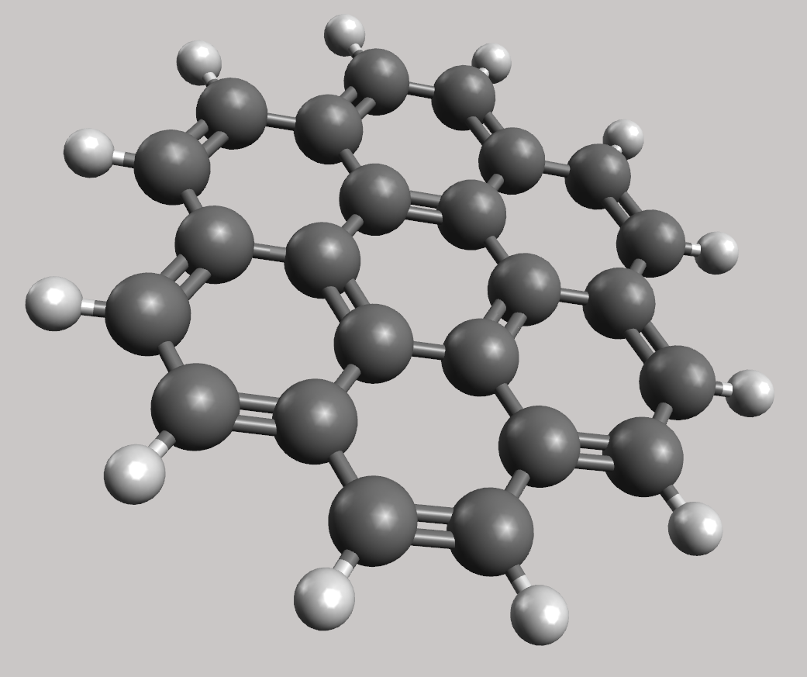
Figure 1: Coronene (C₂₄H₁₂)

NOTE: It is the author’s responsibility to read through the abstract carefully before submitting it.
References:

[1] First F. Author, Second S. Author, Phys. Rev. A 11, 1111 (2001).
[2] First F. Author, Second S. Author, Phys. Rev. A 22, 2222 (2002).

